Clay Cavlovic
GitHub Link: https://github.com/xavix98/ISTG6010-2026
Part 1 Design Phase:
Instead of sketching the UI on paper, I built the prototype using LEGO. The physical build should be treated like the screen you’d be interacting with on a device. One quick technical clarification is that the grid is scaled so that one coordinate space equals a 2×2 LEGO brick. Every ship is built precisely to that 2×2 measurement. That way, what you’re seeing physically is a 1:1 representation of the digital grid.
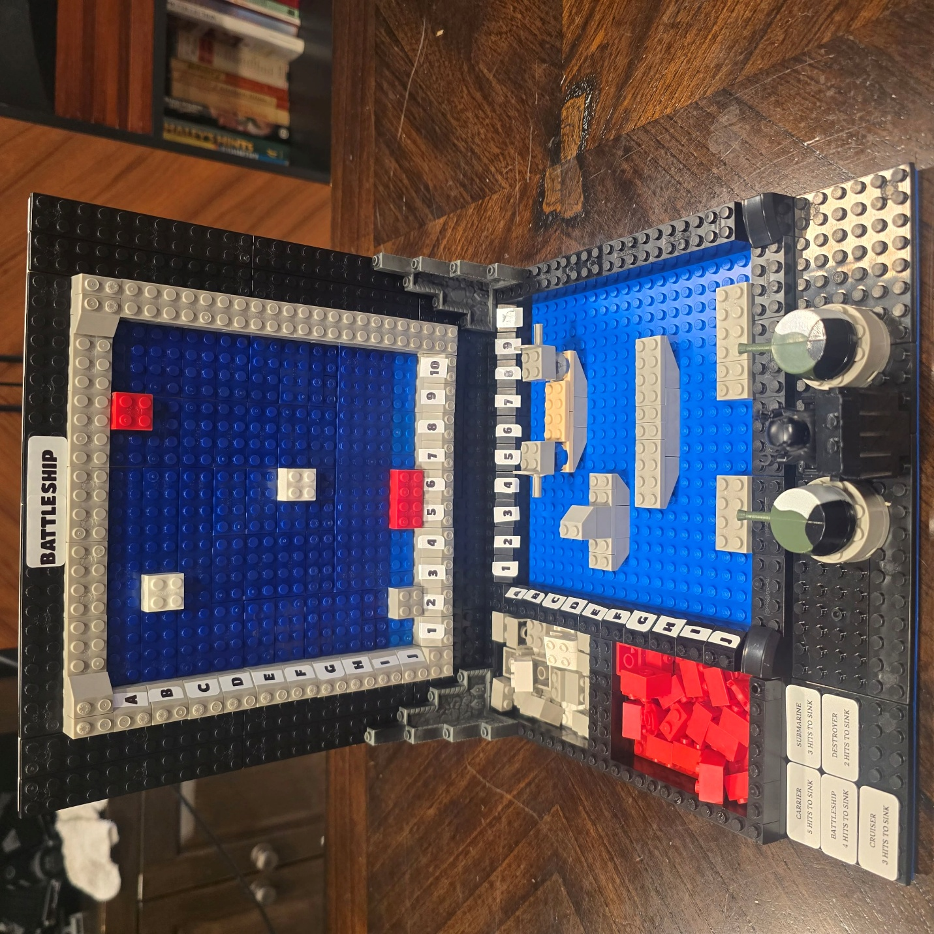
Front View of Board
Figure 1: Front perspective of the primary UI, displaying the dual-board system with the opponent tracking board on top and the player's board below.
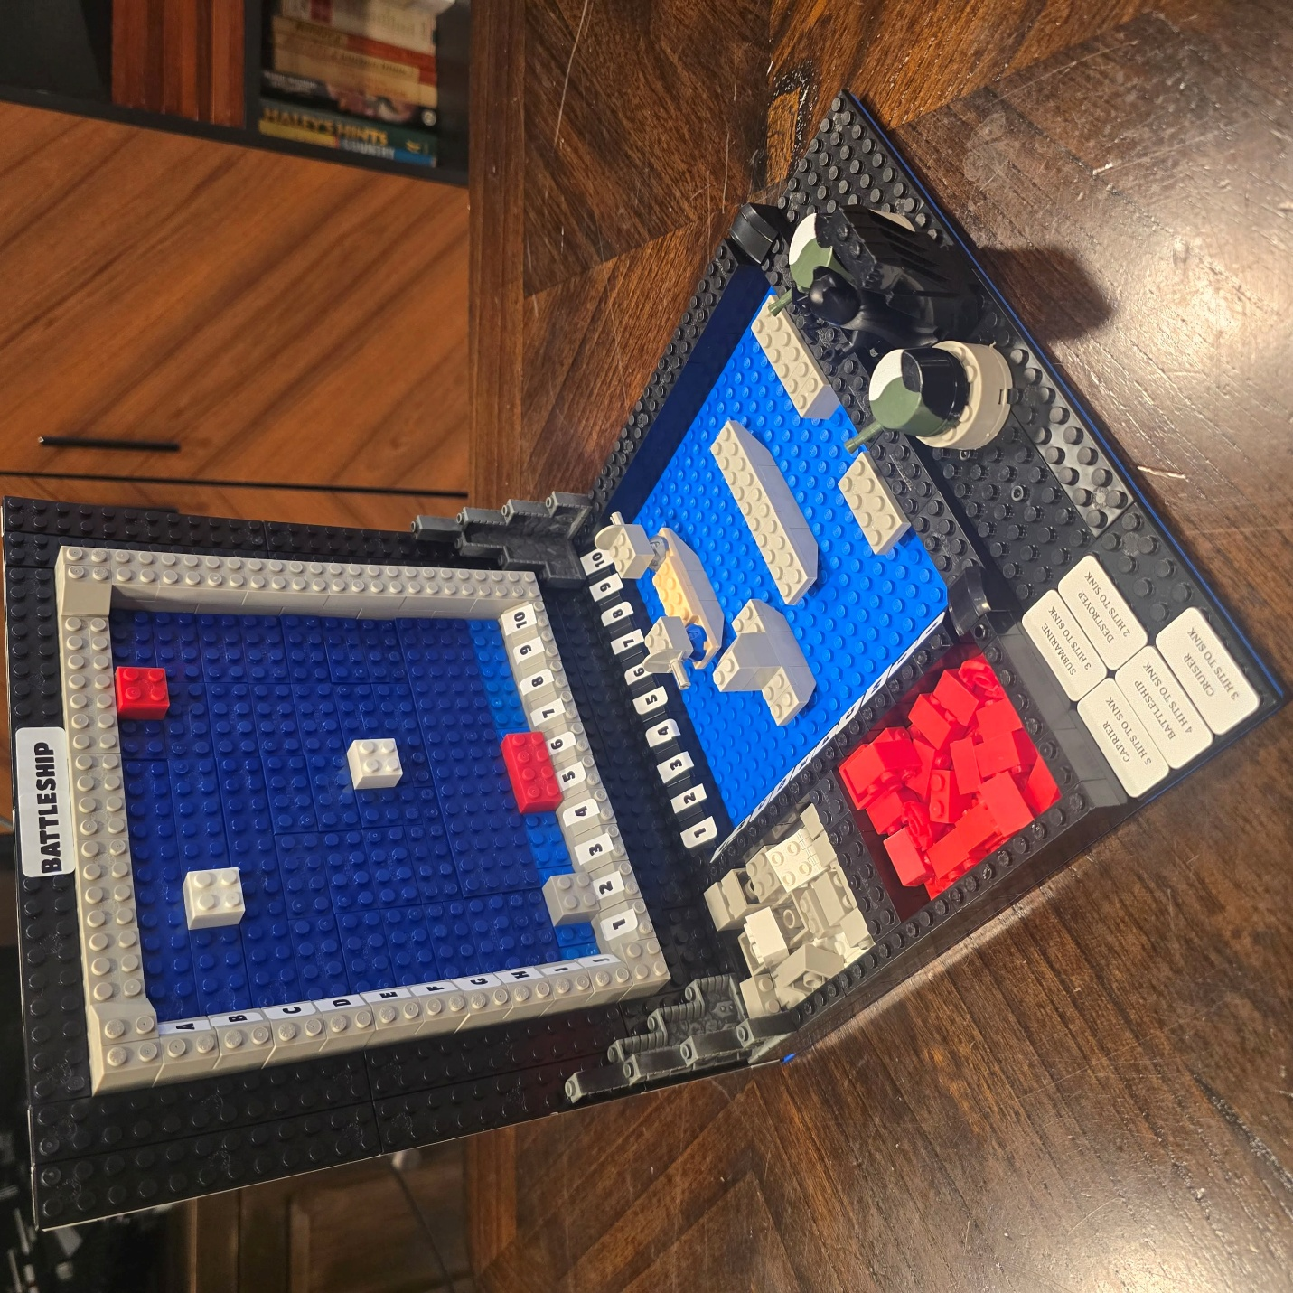
Figure 2: Side profile showcasing the hinged design, which fulfills the core requirement of keeping the player's board hidden from the opponent.
Left Side View of Board
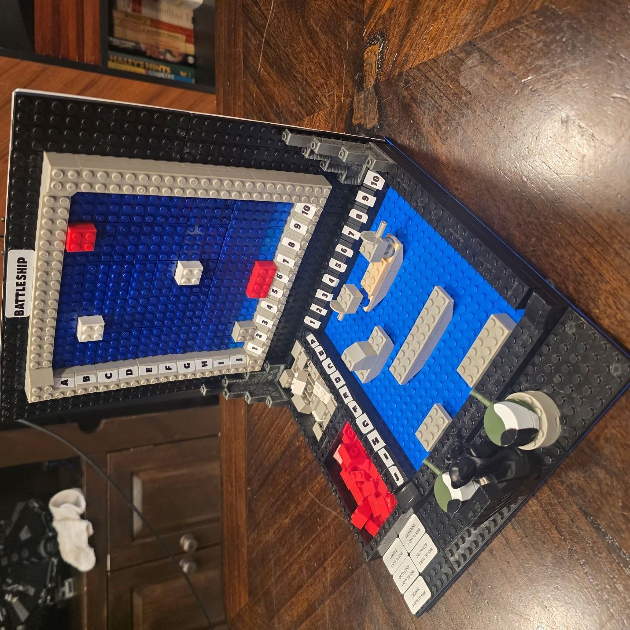
Figure 3: Side profile showcasing the hinged design, which fulfills the core requirement of keeping the player's board hidden from the opponent.
Right Side View of Board
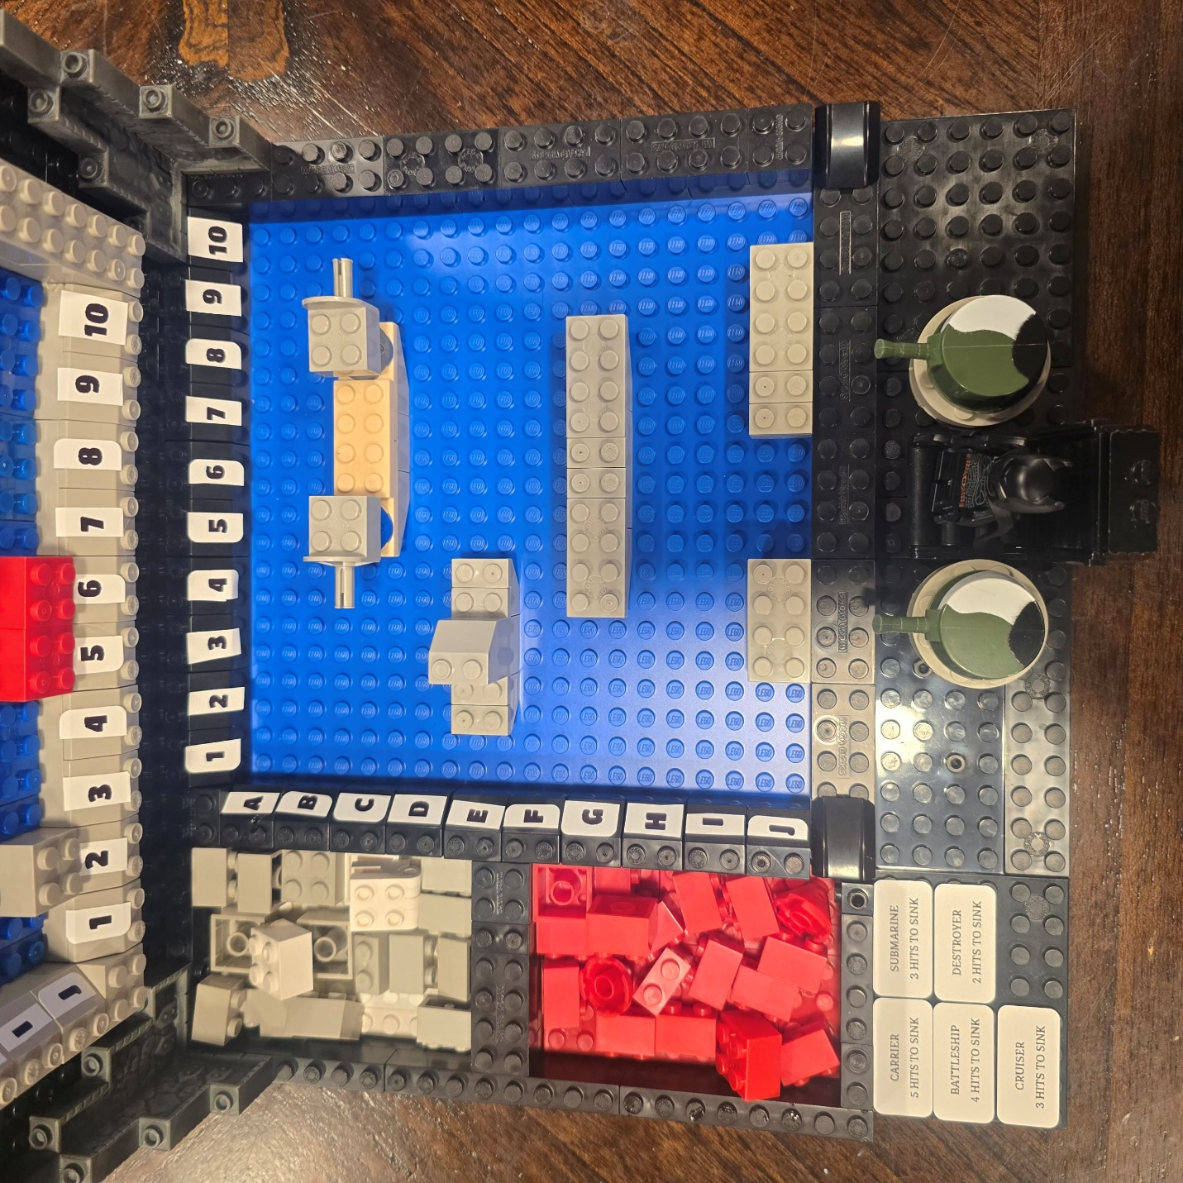
Figure 4: Detailed overhead view of the grid UI, highlighting the A–J and 1–10 coordinate labels and the intuitive hit/miss tracking. Also shows a UI tracker for ships that have been sunk. Will be moved to better location in final design.
Bottom Grid View
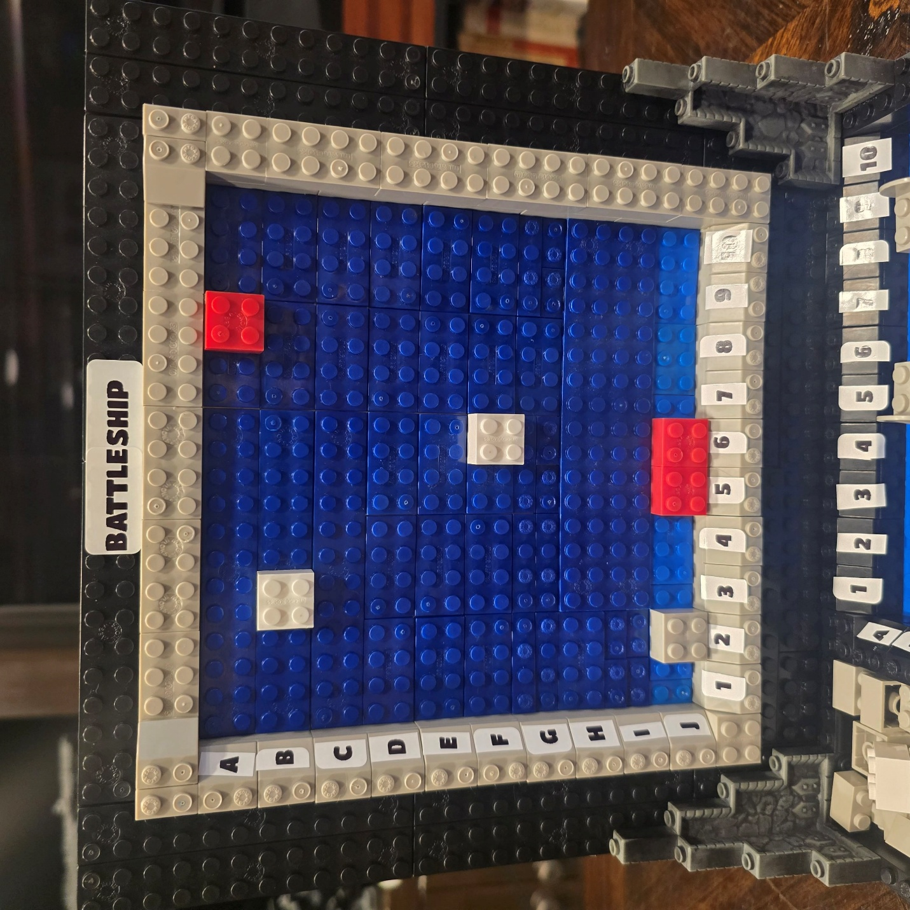
Figure 5: Detailed view of the top grid UI, highlighting the A–J and 1–10 coordinate labels and the intuitive hit/miss tracking.
Top Grid View
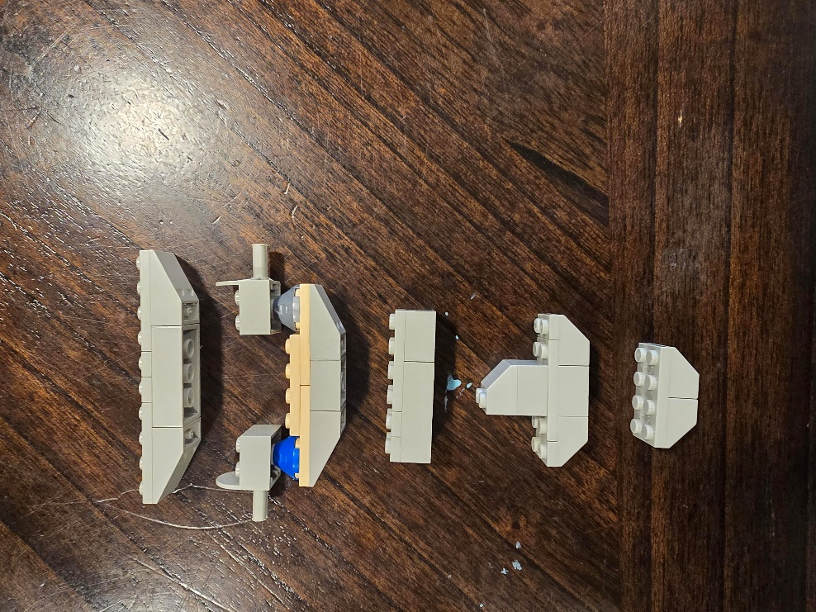
Figure 5 & 6: Top and side profiles of the complete fleet. These physical prototypes serve as the visual baseline for the game's digital assets.
- Carrier model, representing the largest ship asset on the digital grid based on the uniform 2x2 coordinate measurement.
- Battleship model, featuring physical aesthetic touches like turrets that will be translated into digital flairs.
- Submarine model, demonstrating the accurate 1:1 digital scaling used for UI placement.
- Cruiser model, demonstrating the accurate 1:1 digital scaling used for UI placement.
- Destroyer model. Built strictly to the 2x2 LEGO brick scale to represent its exact coordinate footprint on the digital grid.
Destroyer
Cruiser
Submarine
Battleship
Carrier
Boat Top View
Destroyer
Cruiser
Submarine
Battleship
Carrier
Boat Side View
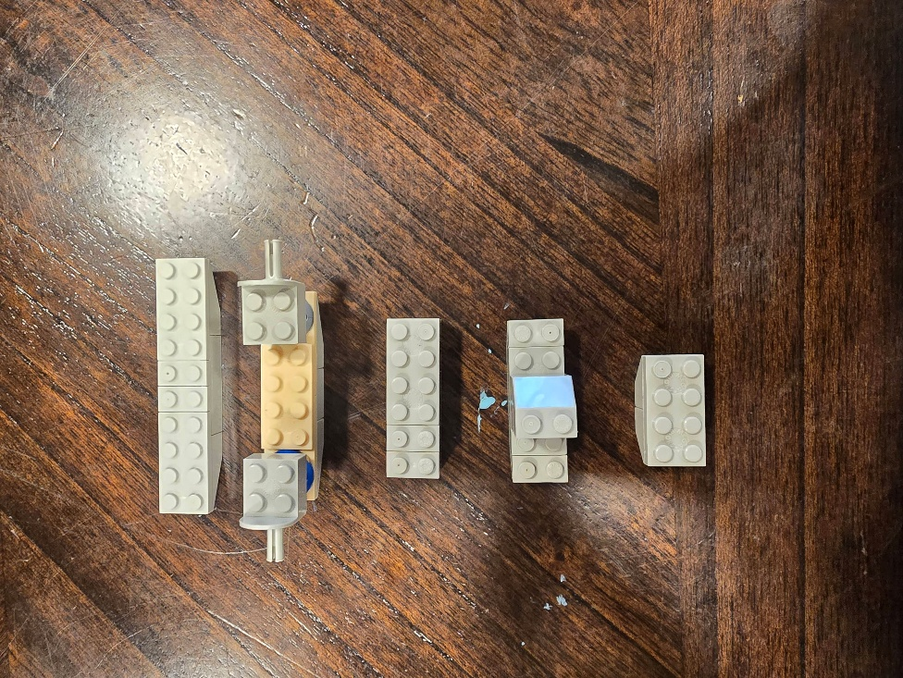
Part 2 Review Design:
I sat down with my reviewer Casandra to walk her through my Battleship UI design, using my physical LEGO prototype as if it were the actual device screen. We walked through a game to gather interactive feedback, which led to a lot of great insights.
Clarity:
She immediately noticed how clear the board was. She pointed out that the labeled grid (A–J and 1–10) mirrors traditional Battleship perfectly. She also mentioned that the color coding, red for a hit and white for a miss, was intuitive and easy to understand right away. The visual separation between the top "tracking board" and the bottom "own board" made perfect sense to her.
Completeness:
When looking at the overall design, she felt the core elements were there, like both the player and opponent tracking boards, accurately sized ships, and hit/miss tracking. However, she suggested having a setup phase UI for someone who wouldn’t know how to properly place their ships. She also noted that there was no visual feedback system to let a player know when they sunk a ship.
Consistency:
We discussed how consistent the design felt. She liked that the grid system, the color usage, and the 2x2 ship scaling were all uniform across both boards. This consistency helped her understand the layout without needing extra explanation.
Scalability:
We talked about how the game could grow in the future. She agreed that the grid and the 2x2 system will scale well to a digital format. To make it even better, she suggested adding modular panels or expandable sections to support larger, variable grid sizes like 12x12. This would also leave room for future features we brainstormed, like radar scans and special weapons.
Usability:
While the familiar gameplay layout reduced the learning curve, we hit a snag during our mock game. She wasn't exactly sure where to "input" a move or select a coordinate if this were an actual screen. We agreed it would be best to add a clearly labeled "FIRE" or "CONFIRM" action area and define an interaction flow like select a row, select a column, and then confirm the action. She also suggested adding an instruction panel or legend directly on the board.
Adherence to Requirements:
She felt the design nailed the core Battleship mechanics, including the dual-board system and accurate ship sizes and rules. She was impressed by the hinged design, pointing out how perfectly it fulfilled the requirement to keep the player's board hidden from the opponent. She did suggest again that including a rule reference directly on the board would be a good addition.
Technical Feasibility:
We briefly discussed how this would be built digitally. She felt confident that the grid system I created would translate very cleanly into a digital UI. She also noted that the modular design maps well to standard digital development practices, making it a highly feasible project to code. We discussed the technical challenge of rendering both the tracking board and the player board simultaneously on a smaller screen.
Optimization Opportunities:
To make the game run smoother and feel more modern, she had some great optimization ideas. She suggested combining the row and column selection into a single tap for the digital version. She also recommended auto-marking hits and misses rather than relying on manual placement and highlighting the last move on the board to keep the game flow clear and fast.
Security Considerations:
We discussed how, in the final design, we need to ensure the opponent's ship coordinates are securely hidden on the server and never exposed in the local code, preventing any players from cheating or hacking the game state.
Innovation and Creativity:
She really loved the aesthetic choices I made, specifically pointing out that the physical turrets and the LEGO figure greatly enhanced the overall visual theme. She highly encouraged me to translate those physical aesthetic touches into digital flairs like adding custom animations, thematic sound effects, or exciting visual feedback whenever a ship is fully sunk.

